Requirements Document

Project: Design an Autonomous Robot

Task: To design an autonomous robot that is capable of navigating to a predetermined position while avoiding obstacles and firing objects at two targets. This is to be done in the shortest time possible.

Document Version Number: 5.0

Date: April 3rd, 2015

Author: Gwyneth Pang and Eric Vuong

Contents

Capabilities 3

Purpose 3

Scope*(Subject to change) 3

Questions: 3

Play Area Specifications: 4

Constraints 5

User Functions 5

Operating Environment 6

Composition of surface 6

Ambient Lighting 6

Performance 6

Compatibility 6

Compatibility re-use 6

Compatibility with Third Party Products 6

Glossary of Terms 6

# Capabilities

## Purpose

The purpose is to create an autonomous robot, mechanical and software aspects with the available resources, notably the three NXT kits and the Java programming language. This robot must localize its position, travel to the shooting area of the 12’ x 12’ field, shoot three ping pong balls into each of the two target areas that are outside of the field, and return to its starting position in the shortest amount of time. Furthermore, the 12’ x 12’ field will contain obstacles, except for the specified zones without obstacles, red zones on the project description map.

## Scope*

### Questions:

*Should the robot use more than one NXT brick?*   
To start, one brick should be used to keep things simple. Week4 Update: The mechanical design has been finalized and only one brick has been used.

*Before starting the software design, should the hardware be completed?*It is important to complete the hardware design first as a slight modification in the hardware can affect the robot’s weight. As a result, the robot’s odometer may fail. Week4 Update: The hardware design was prioritized first and completed as fast as possible in order for the software component to be started.

*Should the robot go past all objects in the middle or sneak into the “safe” zone?*Answer to be determined. More knowledge on the progress of the software and hardware is required. Week4 Update: The obstacle avoidance works very well, and thus the team plans on passing all the objects in the middle. However, depending on the results of the trial demo, the decision may change.

*What is the time limit for each phase of the competition?*Answer to be determined. Should be asked during the first meeting.Week4 Update: There has been no definitive answers yet.

## Play Area Specifications:

The area is a 12 x 12 enclosure containing several obstacles. The each tile’s dimension is 30.48 cm x 30.48 cm. Thus, the robot must travel at least approximately 4 meters to reach its destination. The odometer design must then be precise enough for distances over 4 meters. The tiles in red as indicated in area 6 and 8 are guaranteed to be free of obstacles. For the rest of the area, there will be obstacles placed randomly. To fire the ping pong balls, the robot must be on the green tiles on area 9.T1 and T2 are the target location where the robot will have to fire its ping pong balls to (no more than 3 ping pong balls may be fired at any one target). Once the robot is done firing, the robot must navigate back to the initial position (0,0) as indicated in **Figure 1**. and face North.

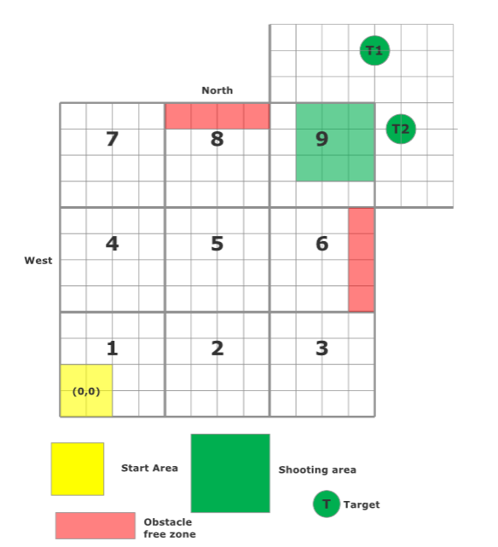

**Figure 1.**  A representation of the area.

# Constraints

Please refer to the constraints document for information about the constraints.

# User Functions

During the competition, the robot must be autonomous. In other words, there can be no interaction with the robot during the operation. Before the operation, the robot will be placed at an arbitrary position pointing in a random direction within the yellow zone of area 1. The ping pong balls can be loaded to the robot manually prior to the operation. However, during the operation, the robot must be autonomous enough to fire the balls.

# Operating Environment

## Composition of surface

Refer to the environmental issues section in the Constraint document.

## Ambient Lighting

Refer to the environmental issues section in the Constraint document.

# Performance

Refer to “Play Area Specifications” under “Scope” in tables of content for more information about the performance requirements.

# Compatibility

## Compatibility re-use

## In the design of the robot, the software from labs 1 through 5 will be reused, but re-calibrated for the new design. The navigation lab’s code will be re-used, in order to fulfill the traveling part of the task. Then, the localization lab will be re-used for the localization part of the task. The wall follower and the odometer from the first and the second labs were already implemented in the navigation lab. Lastly, the ballistics lab will cover the ballistics part of the task. Thus, the only software that needs to be developed is the implementation of the labs in order to make the robot function. However, many parts will need to be improved in order to accommodate the larger field. For example, in this project, the light sensor and the ultrasonic sensor’s filters need to be adjusted into differential filters rather than absolute values, due to the environmental conditions found in the constraints document. The odometer and the odometer correction need to be improved in order to reduce the amount of error on the large competition floor. Finally, the obstacle avoidance needs to be improved due to the unknowns surrounding the obstacles in the competition floor. Racing conditions may potentially be introduced due to the amount of threads running simultaneously, thus the robot will try to only run one thread at a time.

## Compatibility with Third Party Products

The use of a paper towel roll, rubber bands, and cardboard will be employed. There are no problems using the rubber band in our launcher in order to generate elastic energy in order to launch the ping pong ball. Another elastic is used in order to tie a piece of Lego to the paper towel roll, which also has no issues. It is also very structurally solid. Lastly the cardboard will be taped onto the side of the ultrasonic sensor and around the light sensor, which also has no issues.

# Glossary of Terms

N/A